How to run this file and the resultant output :

Step 1: press the play button if youre using vs code as pointed by the pointer in the below screenshot ( the play button is located at the top right corner of the below screenshot :
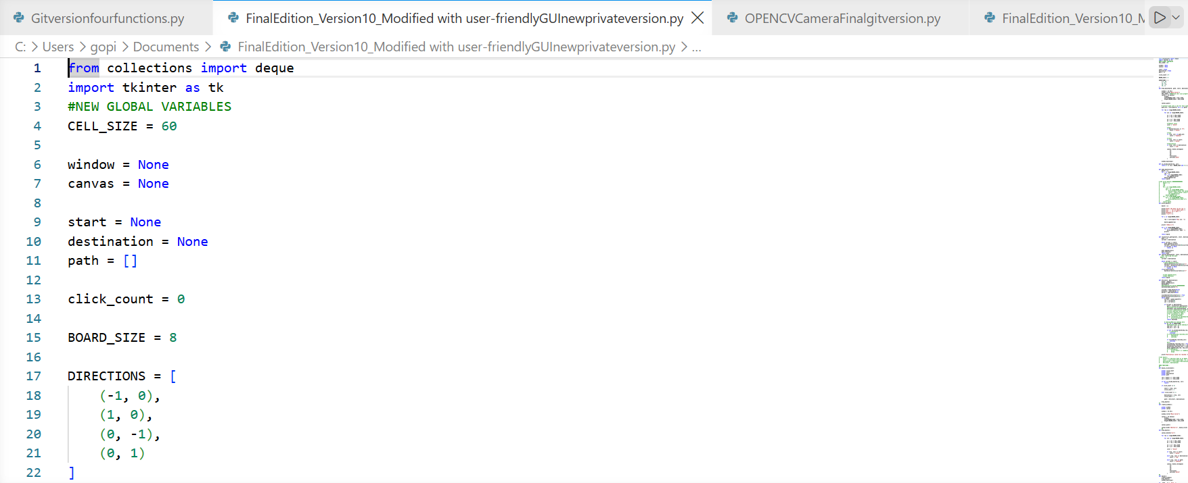
Step2: Now choose the start and the end-point squares as you wish :
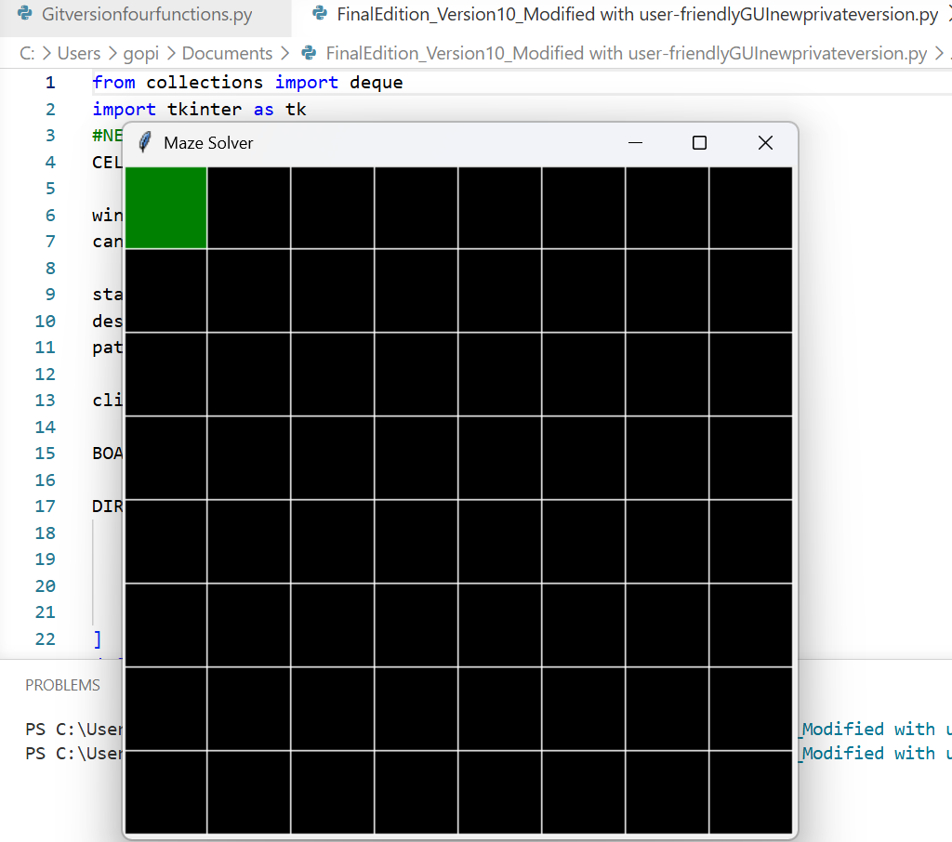

Step 3 : the end result will be displayed :
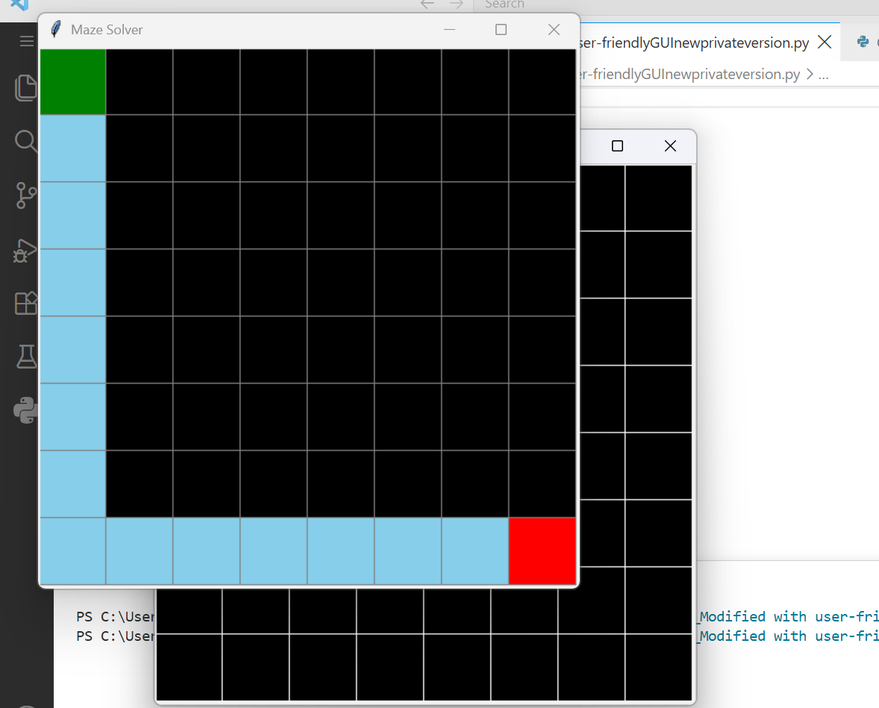

So the green square is the start-point that I chose on this 8x8 grid
And the Red-square is the destination square i chose here

